<https://degreed.com/plan/3585456?newwindow=true>



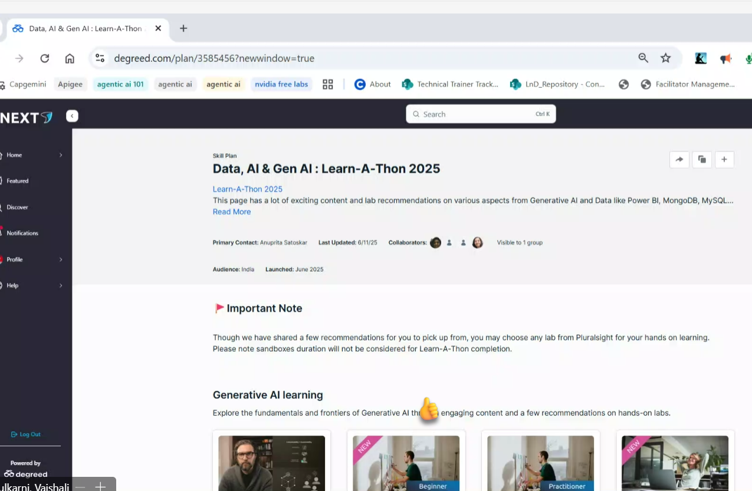

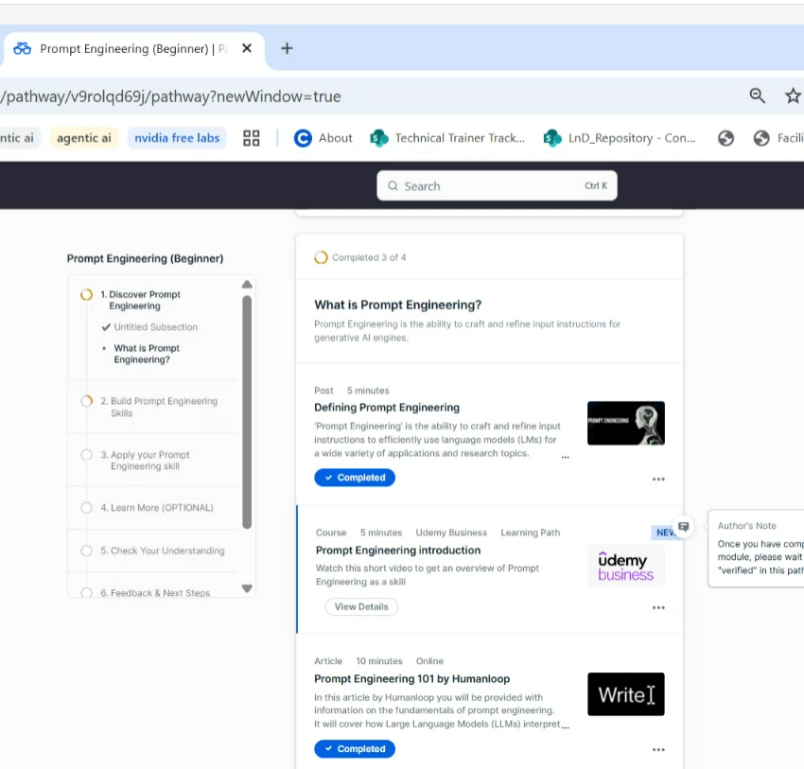

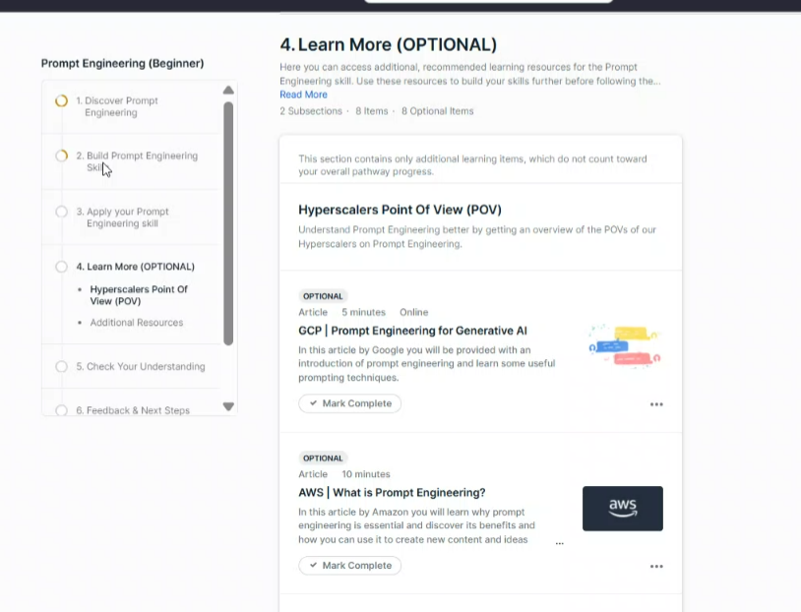

[Data, AI & Gen AI : Learn-A-Thon 2025 | Plan | Degreed](https://degreed.com/plan/3585456?newwindow=true)

LLMs – large Language models

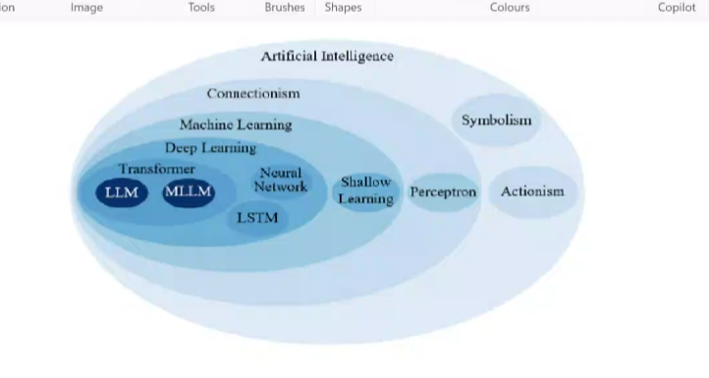

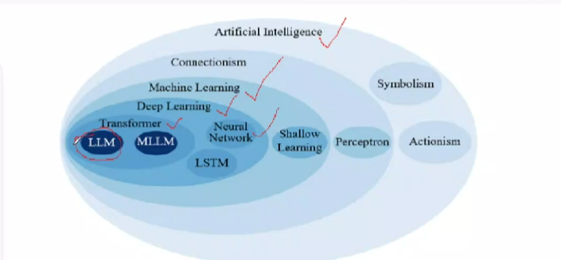

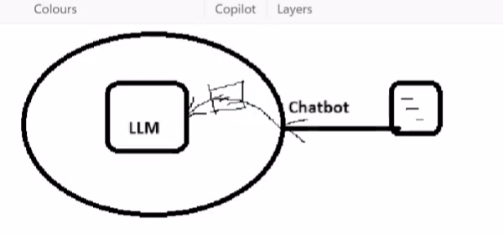

Token – each end user message is broken down into tokens and the response also comes in tokens.

Pricing is impact on no. of tokens is increased

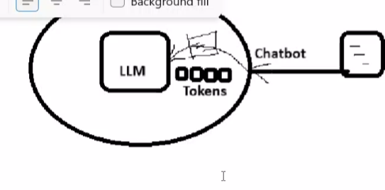

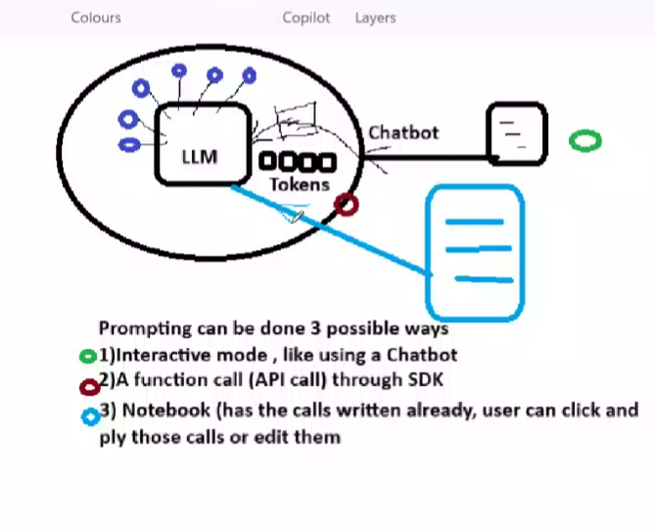



1. Explain the concept of Generative AI to a teenager

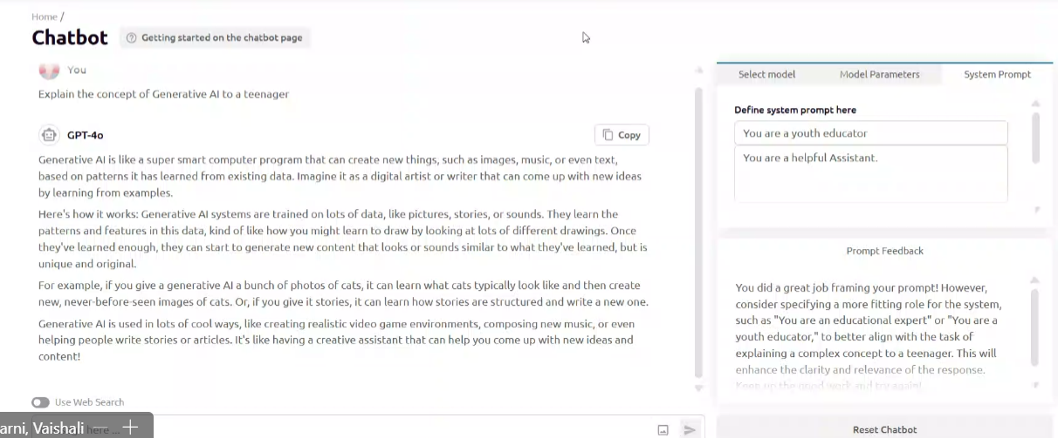

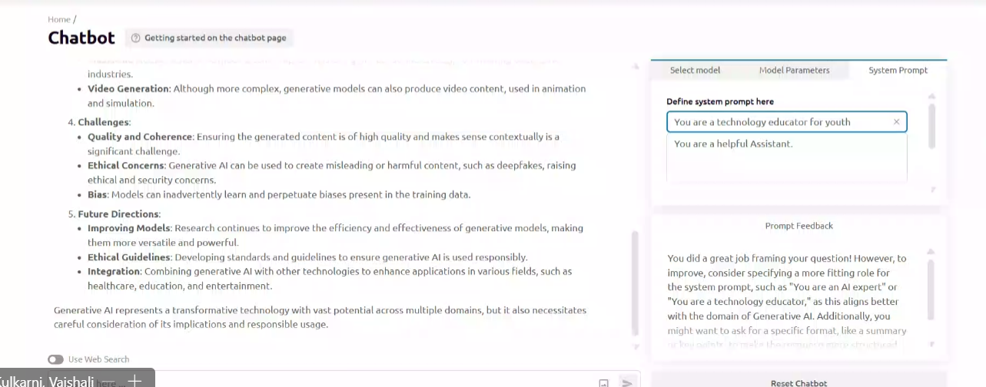

Explain the concept of Generative AI in 5 lines

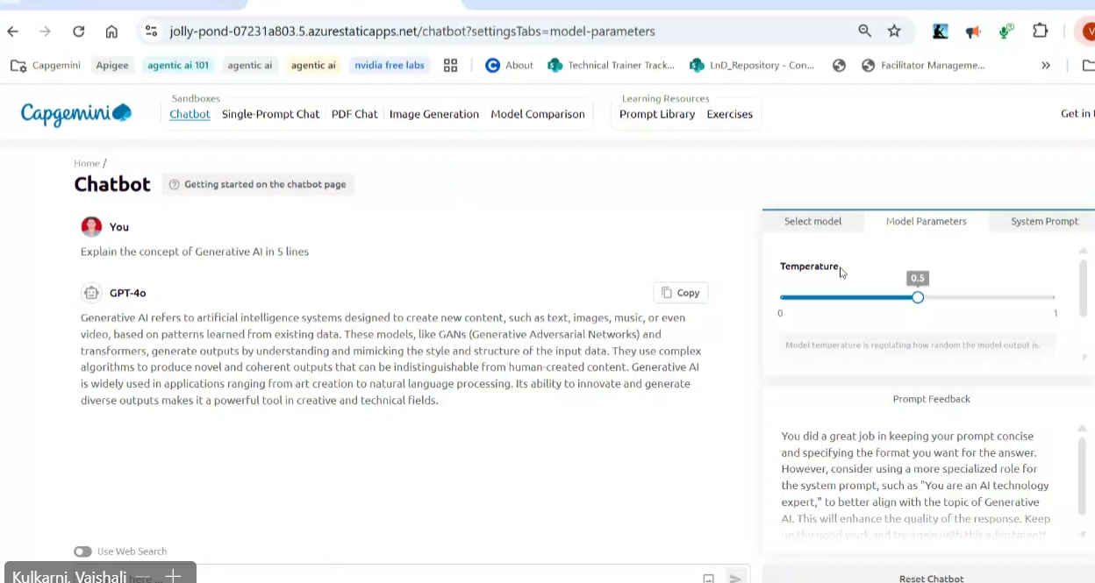

Degree of creativity is nothing but temperature.

If we increase the temperature the quality of the output will be in more creative manner etc.. like that..

For ex : 1 plus 1 we can get 2, if we increasing the temperature it may be 11 ( creative way)

2.Classify the following comment’s sentiment as positive, negative,  
or neutral  
###  
Comment: “Great course! I’ve learned so much!”  
Sentiment:

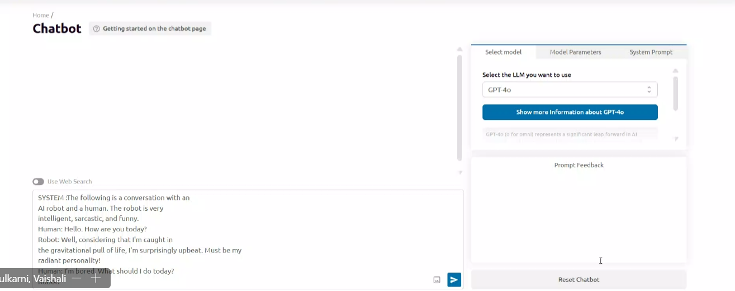

3. SYSTEM :The following is a conversation with an  
AI robot and a human. The robot is very  
intelligent, sarcastic, and funny.  
Human: Hello. How are you today?  
Robot: Well, considering that I'm caught in  
the gravitational pull of life, I'm surprisingly upbeat. Must be my  
radiant personality!  
Human: I’m bored. What should I do today?  
Robot:

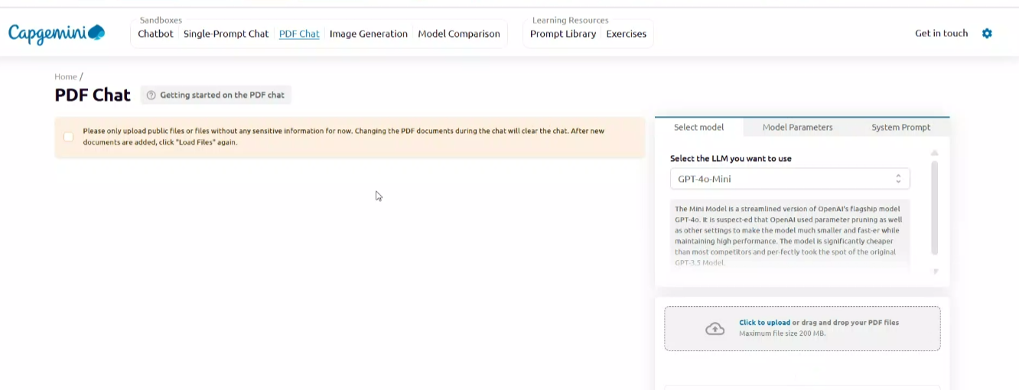

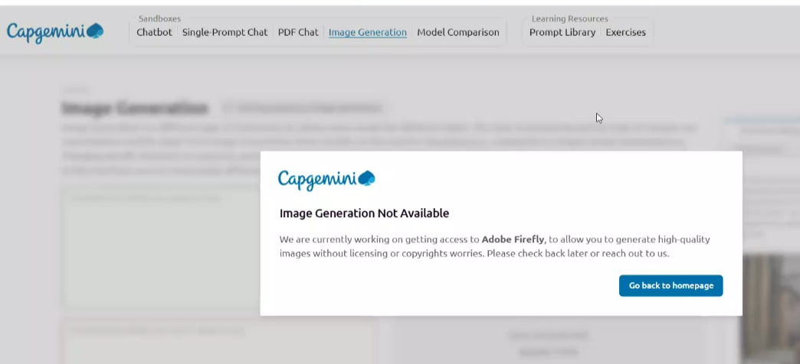

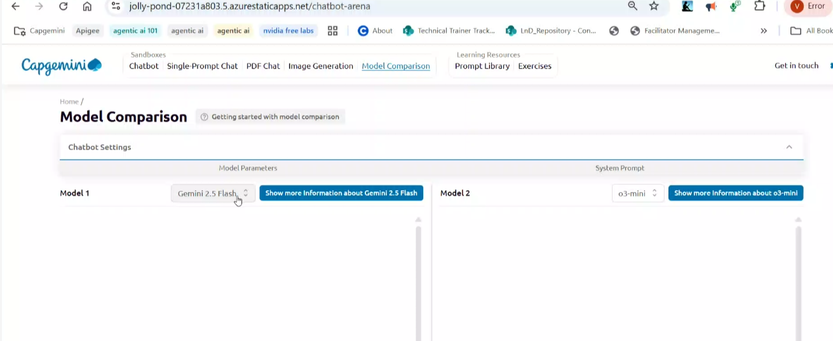

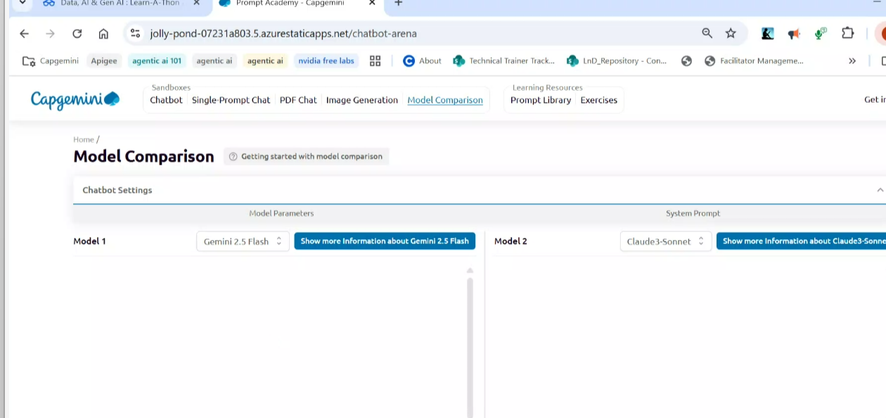

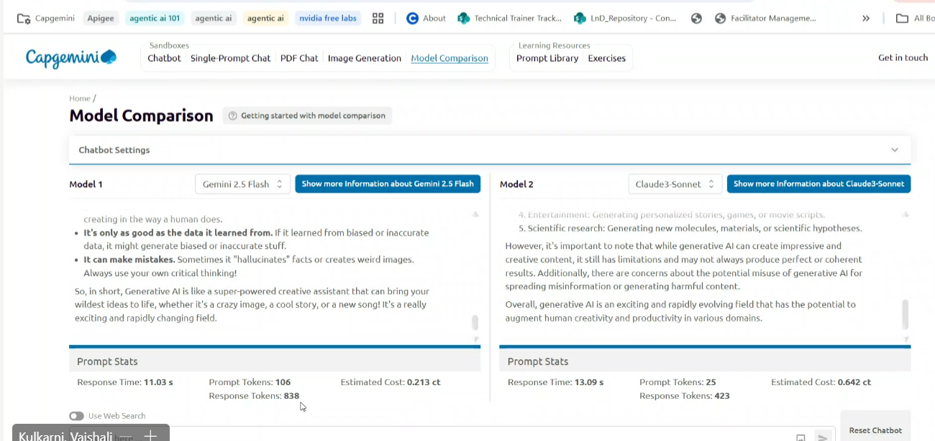

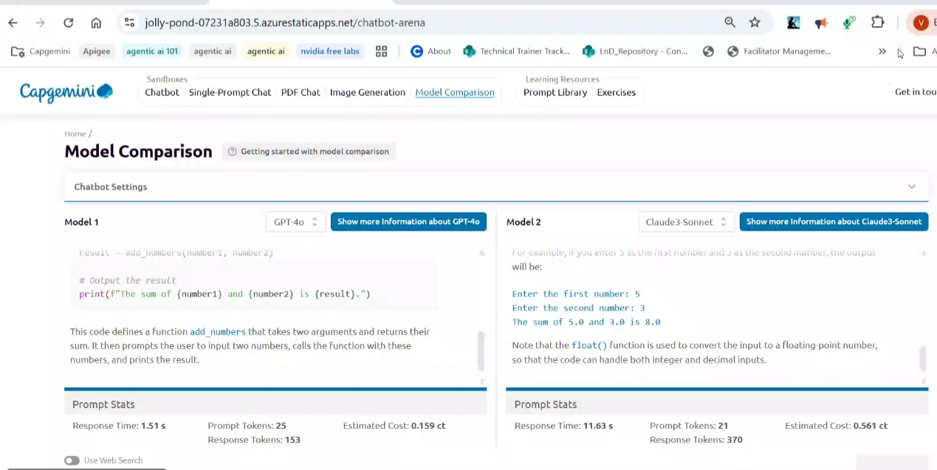

<https://openrouter.ai/>

OpenRouter

The unified interface for LLMs. Find the best models & prices for your prompts

<https://jolly-pond-07231a803.5.azurestaticapps.net/chatbot?settingsTabs=model-parameters>

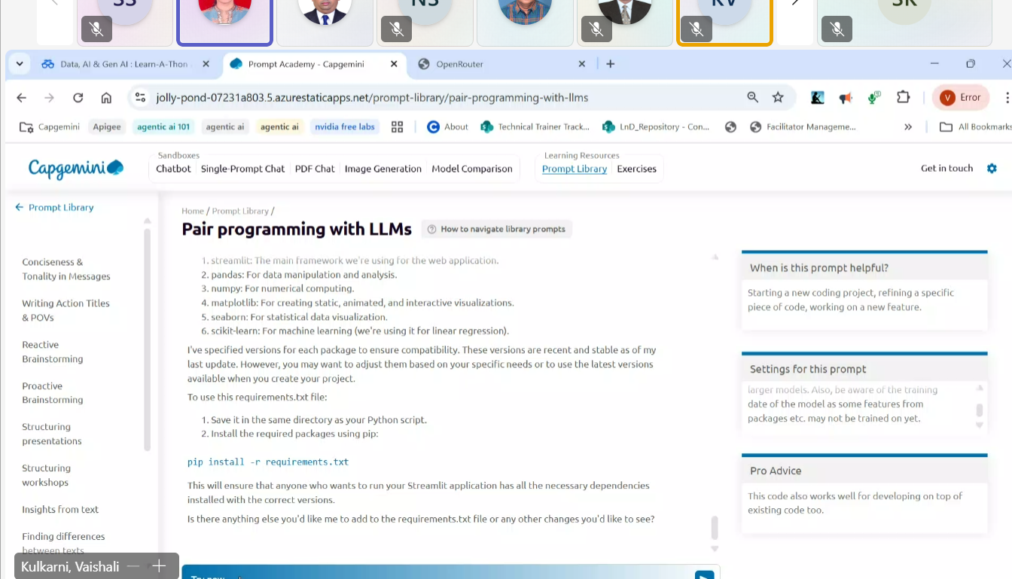

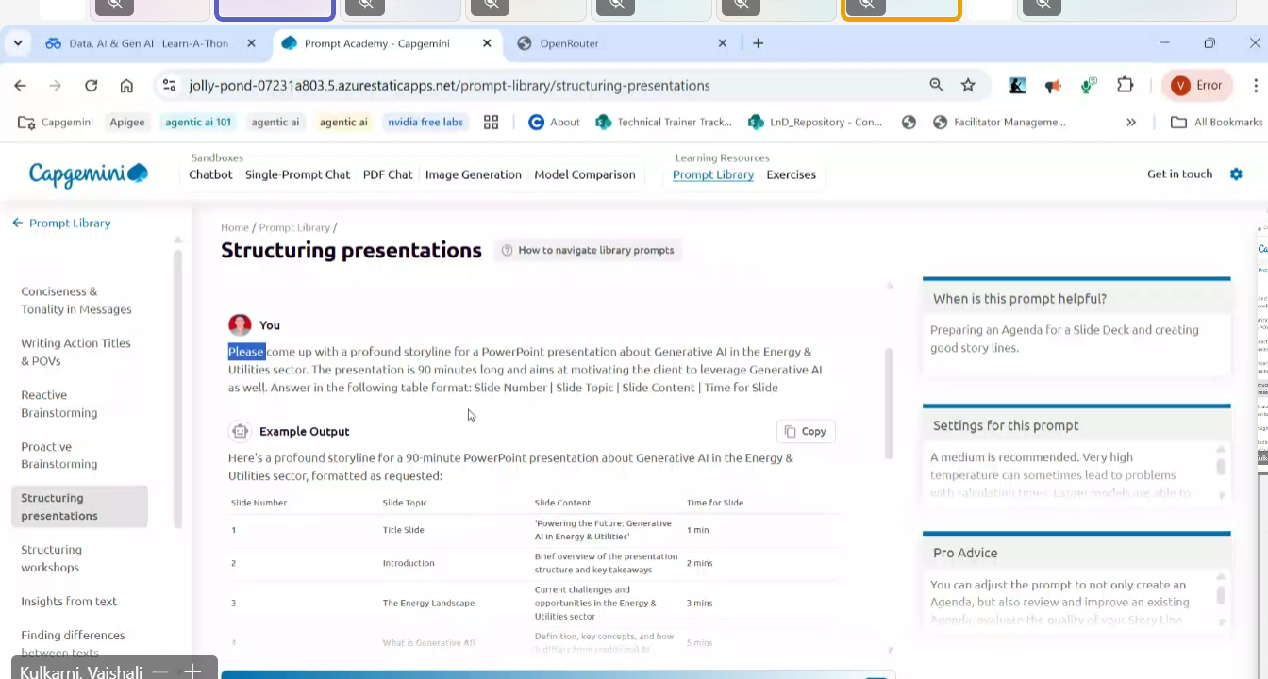

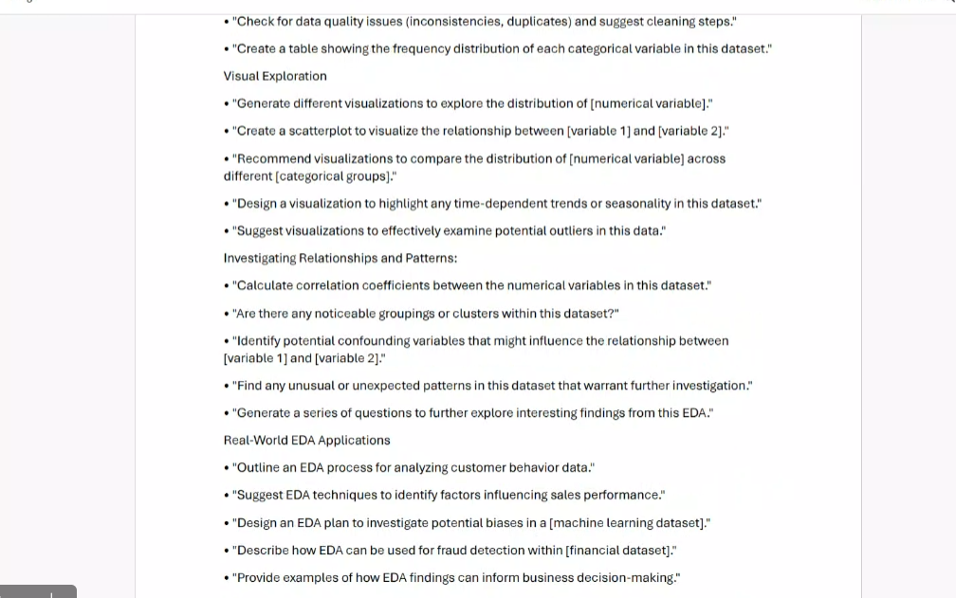



TODO : [**Understanding Agentic AI**](https://degreed.com/pathway/79xy0nv3pk/pathway?newWindow=true)

[Understanding Agentic AI | Pathway | Degreed](https://degreed.com/pathway/79xy0nv3pk/pathway?newWindow=true)

**Plan :** [**Agentic AI**](https://degreed.com/plan/3489144?newWindow=true)

[degreed.com/plan/3489144?newWindow=true](https://degreed.com/plan/3489144?newWindow=true)

[generative-ai/gemini/prompts/intro_prompt_design.ipynb at main · GoogleCloudPlatform/generative-ai · GitHub](https://github.com/GoogleCloudPlatform/generative-ai/blob/main/gemini/prompts/intro_prompt_design.ipynb)

<https://app.pluralsight.com/library/>

Sign In | Pluralsight

<https://app.pluralsight.com/hands-on>

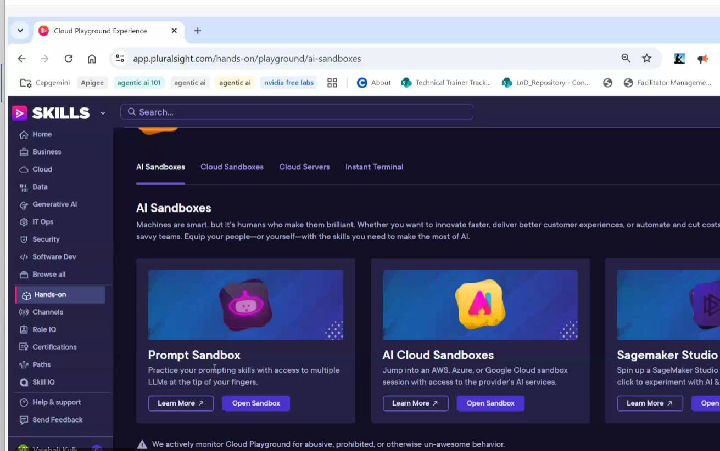

<https://app.pluralsight.com/hands-on/playground/ai-sandboxes>

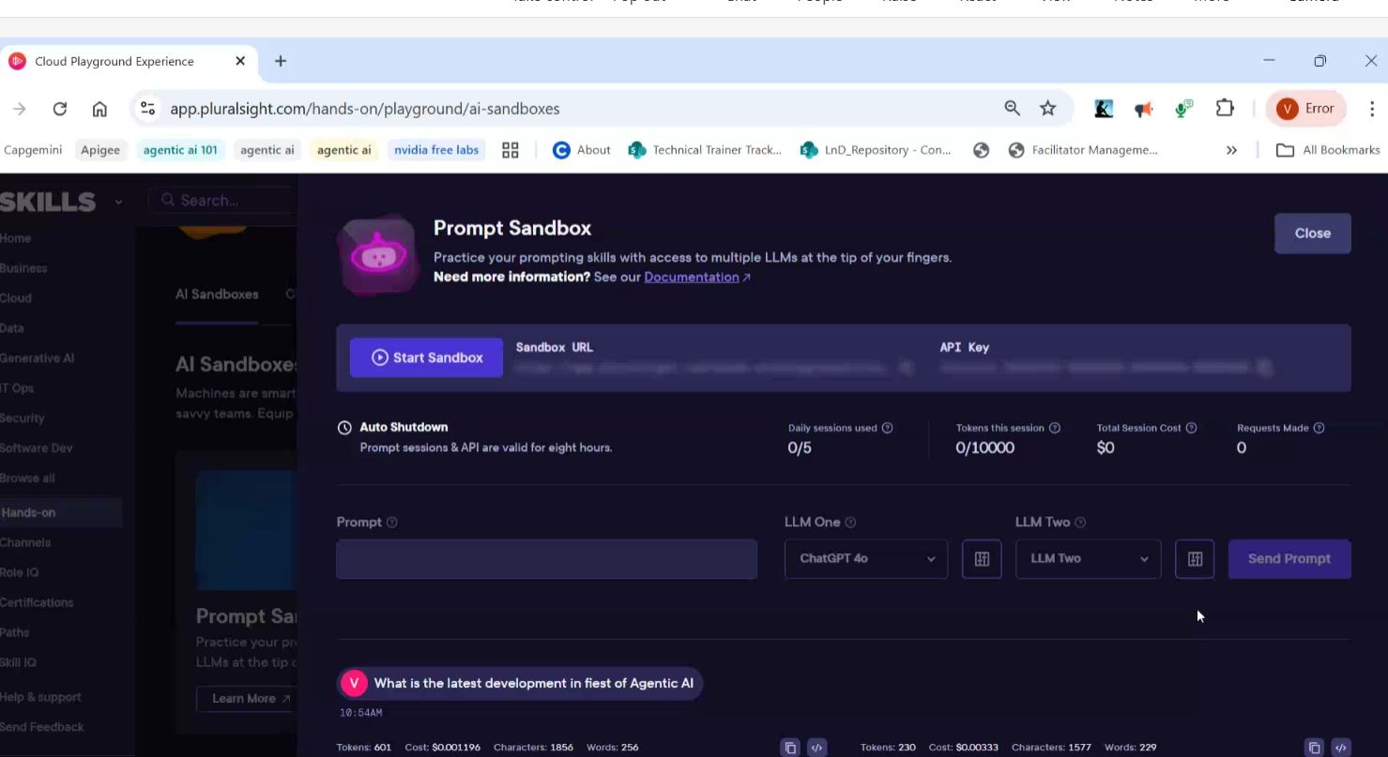

Select labs checkbox

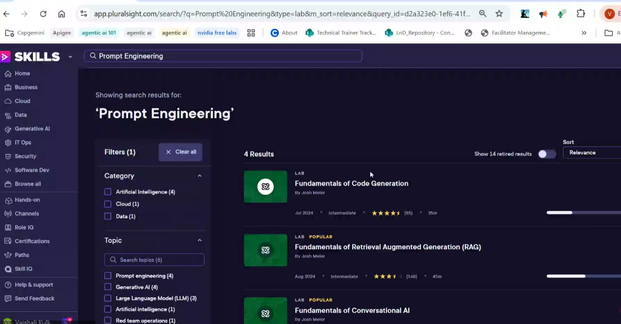

<https://www.youtube.com/watch?v=bYA3QsbbUEc&list=RDbYA3QsbbUEc&start_radio=1>

Response from Chatbot 

The temperature parameter in generative AI models, particularly in language models like GPT, controls the randomness of the output. It influences how the model decides between different possible next words or tokens when generating text.

- Low Temperature (e.g., 0.1): The model becomes more deterministic, favoring the most likely or predictable choices. This can lead to more coherent and focused outputs but may lack creativity or diversity.

- High Temperature (e.g., 1.0 or above): The model's choices become more random, allowing for more creative and varied outputs. However, this can also result in less coherent or more unpredictable text.

Adjusting the temperature allows users to balance between creativity and coherence based on their specific needs for the generated content.